Partial Products & Area Model of Multiplication:

Steps:

1. Draw a rectangle
2. Break each factor into place value (expanded form).
3. Label the length and width of rectangle with each factor.
4. Multiply the length and width of each part of model.
5. Add pieces (partial products) to get total product.

Example: 7 X 13

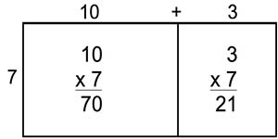

Example: 6 X 4,835

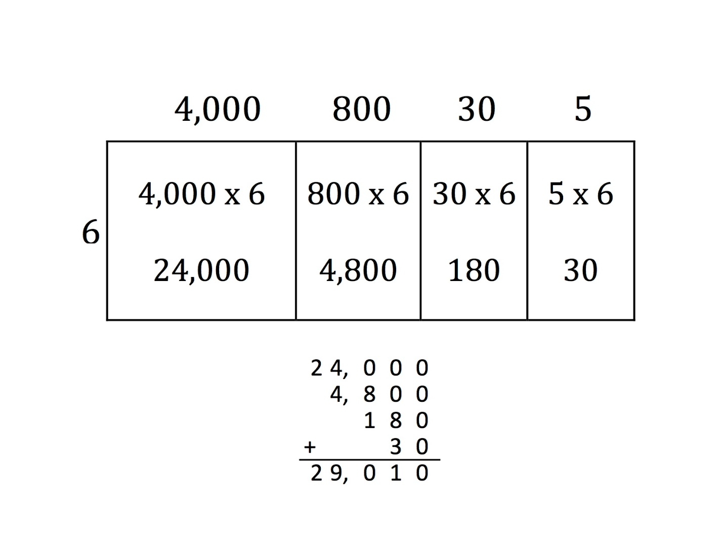

Example:

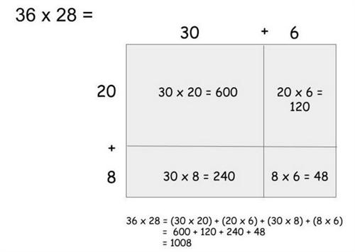

Example: 18 X 23

